Part 1
Method
In part 1, we want to measure the speed of sound in two different strings we pluck on a ukulele. We note the following equations:
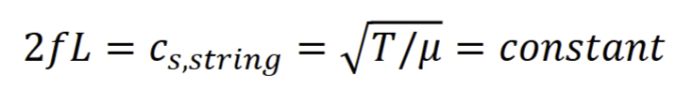
Propagated partial derivatives:
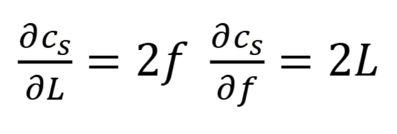
We predict that the two strings will have a slightly different speed of sound, as each string should make a separate primary noise (primary harmonic). We will be measuring the lengths of the strings with a simple measuring tape, with an error measurement of 0.5mm. We will measure frequencies off of Audacity, which is a digital measurement, and our error for this is just 1 Hz.
We compute what the real speed of sound is for the two strings from the measured data, and use T-scores between the two measurements to highlight their differences. We also demonstrate the error uncertainties of our measurements.

Data
We measure the lengths of our two strings (the top two). We then take 6 samples of each string’s plucking to get an average of the primary frequency for the two strings.

Lengths (+/- 0.5mm) | Primary Frequency (+/- 1 Hz, +/- 0.1dB) | Computed Speed of Sound | Propagated Error on C
35.5cm | 391Hz @ -40.9dB | 277.6 m/s | +/- 0.93 m/s
35.5cm | 261 @ -44.9dB | 185.3 m/s | +/- 0.76 m/s

We then compute the T-scores of the two computed speeds of sound:
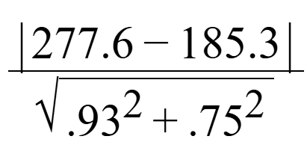
Which gives us a T-score of ~77, which is very distinguishable.

Conclusion
Due to the computed velocities being different, we believe that the two “rules” of four the lab manual talks about that are “violated” is that the tensions in the two strings are different and that the mass per length is different due to different diameters. The two strings we picked are one that is very thin and one that is very thick. In addition, due to us not having tuned the thing at all, it’s extremely likely that the tensions in the strings are different as well.

We can see from our T-score of 77 that the two speeds of sound in the strings are distinguishably different. This is also clearly visible from the computed speeds of sound. Another group had a very similar approach and came to the same conclusion. We conclude for Part 1 that 1) the two strings do in fact have separate sounds and 2) the equations referenced in the method for Part 1 hold true for the ukulele.

Part 2
Method
Firstly we answer the question about bone conduction. We argue that it appears lower to you as you speak due to the lower frequency waves (and thus lower energy) propagating through the solid material in your skull better than in the air, meaning you “hear” them more from inside your skull as opposed to the sound waves in the air.

We tuned our Ukulele according to the lab manual, which took very little time.
1. The relationship between pitch and frequency is linear, that is:
𝑃 = 𝑘𝐿(𝑓 − 𝑓𝑐4 )
2. The relationship between pitch and frequency is logarithmic and obeys the Weber-Fechner Law:
𝑃 = 𝑘𝑊𝐹 log (𝑓/𝑓𝑐4)
3. The relationship is more complicated than either of these.

We want to evaluate which of these models is accurate. We will verify if the two K values are constant (not to each other, but for multiple measurement points on the instrument):
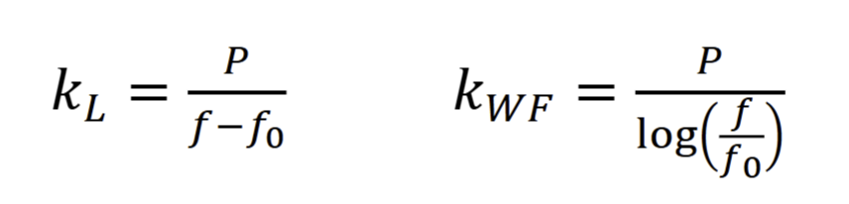
We also have propagated errors:
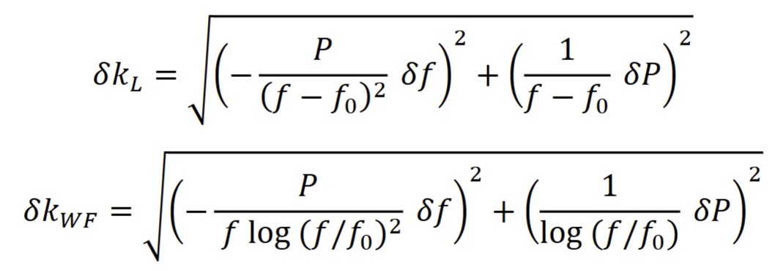

We will use error propagation and T-scores between our computed K values to determine if the model(s) are identical or not. To do this all, we will collect several data points for different frequencies and pitches. We then T-score each set of K values against each other to determine how much they are changing. We then evaluate WHICH equation actually holds. We suspect it will be the Weber-Fechner law, as it includes a logarithm, and we know sound is not linear.

Data
We note that our f0 is 261Hz = C4. We use the propagated error equations from above for the error columns. We also note that we used a value of 0.8 for dP instead of simply 1, as frequencies in between pitches are more discernible than just per-pitch (if that makes sense. Finn said it’s okay :) )

Note (Frequency, name) | Pitch Value (according to Lab Manual) | KL value | KL Error | KWF value | KWF Error
D4, 293Hz @ -34dB | 2 | .0625 | .022 | 39.819 | 16.16
G4, 394Hz @ -30.4dB | 7 | .0526 | .006 | 39.138 | 4.50
F5, 705Hz @ -46.8dB | 17 | .0383 | .0018 | 39.393 | 1.86
C5, 528Hz @ -34.8dB | 12 | .0449 | .0030 | 39.217 | 2.66
B4, 496Hz @ -31.8dB | 11 | .0468 | .0034 | 39.449 | 2.88
A#4/Bb4, 470Hz @ -37.6dB | 10 | .0478 | .0038 | 39.145 | 3.15

We then highlight the T-scores of the KL and KWF entries compared to each other.
These values were computed with a Python script instead of manually:
import numpy as np
def compute_t_scores(values, errors):
t_scores = []
for i in range(len(values)):
for j in range(i + 1, len(values)): # Ensure j > i to avoid duplicates
t_score = abs(values[i] - values[j]) / np.sqrt(errors[i]**2 + errors[j]**2)
t_scores.append(((i, j), t_score))
return t_scores

Pair-wise T-scores for KL:
Pair (0, 1): T-score = 0.43
Pair (0, 2): T-score = 1.10
Pair (0, 3): T-score = 0.79
Pair (0, 4): T-score = 0.71
Pair (0, 5): T-score = 0.66
Pair (1, 2): T-score = 2.28
Pair (1, 3): T-score = 1.15
Pair (1, 4): T-score = 0.84
Pair (1, 5): T-score = 0.68
Pair (2, 3): T-score = 1.89
Pair (2, 4): T-score = 2.21
Pair (2, 5): T-score = 2.26
Pair (3, 4): T-score = 0.42
Pair (3, 5): T-score = 0.60
Pair (4, 5): T-score = 0.20
Pair-wise T-scores for KWF:
Pair (0, 1): T-score = 0.04
Pair (0, 2): T-score = 0.03
Pair (0, 3): T-score = 0.04
Pair (0, 4): T-score = 0.02
Pair (0, 5): T-score = 0.04
Pair (1, 2): T-score = 0.05
Pair (1, 3): T-score = 0.02
Pair (1, 4): T-score = 0.06
Pair (1, 5): T-score = 0.00
Pair (2, 3): T-score = 0.05
Pair (2, 4): T-score = 0.02
Pair (2, 5): T-score = 0.07
Pair (3, 4): T-score = 0.06
Pair (3, 5): T-score = 0.02
Pair (4, 5): T-score = 0.07

Conclusion
Based on our T-score analysis,the linear equation produced values mostly below 1 with significant variability, rendering its results statistically inconclusive. In addition, the T-scores vary from each other significantly.

On the other hand, the T-scores for the Weber-Fechner law are MUCH more consistent with each other, as well as being significantly smaller in value, telling us that the variance in the computed values of K for the law are a lot smaller than the linear “law”.

We conclude that the Weber-Fechner law holds, and is the correct equation to use for these types of experiments. Its data aligns very closely with what we expect to see from sound. The perception of pitch is not changed because of the law, but due to the frequency that is being played (which is really what generates the appearance of pitch). We do not think it apt to compare pitch and loudness - they are two different things being measured. Even though they are both grouped under “sound”, one is the result of changing frequencies, while the other is the result of changing the energy being output at a specific frequency. We did not notice that loudness depended on pitch during our data collection.

Furthermore, our observations regarding the basilar membrane–specifically, the increase in mass per unit length and the corresponding decrease in tension towards the center–help explain why different regions resonate with different frequencies. The logarithmic spacing of resonant frequencies, as predicted by the Weber-Fechner Law, aligns well with the known mechanical properties of the basilar membrane.

